Stock Report

Brad Boehmke

2022-07-28

## AMZN Recommendation: BUY

Based on our internal trading algorithm, we believe that the **AMZN** stock will **increase** in price during the next trading period.

## Price History

The chart below is made with the quantmod R package, a widely used package for collecting and visualizing financial data in R. You can learn more about quantmod at the website <www.quantmod.com>.

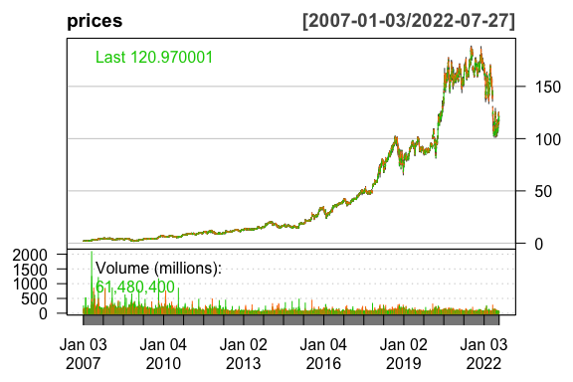

## Method

This forecast was predicted with the *recency algorithm*, a simple—probably useless—method for determining stock prices. The recency algorithm predicts that the next price movement, $M_{j}$, will be in the same direction as the most recent price movement. $M_{i}$.

$$M_{i}=Close_{i}−Open_{i}$$

$$M_{j}=\left\{\begin{matrix}>0, & \text{if }M_{i}>0 \\ ≤0, & \text{if }M_{i}≤0\end{matrix}\right.$$

## Raw Data

The table below displays the most recent 10 days of price data for the AMZN stock.

Stock information for previous 10 business days

|  | AMZN.Open | AMZN.High | AMZN.Low | AMZN.Close | AMZN.Volume | AMZN.Adjusted |
| --- | --- | --- | --- | --- | --- | --- |
| 2022-07-14 | 110.24 | 111.18 | 107.58 | 110.63 | 51163100 | 110.63 |
| 2022-07-15 | 112.50 | 115.59 | 111.59 | 113.55 | 83891100 | 113.55 |
| 2022-07-18 | 115.00 | 117.24 | 113.15 | 113.76 | 59115400 | 113.76 |
| 2022-07-19 | 115.70 | 118.95 | 114.03 | 118.21 | 60990000 | 118.21 |
| 2022-07-20 | 118.62 | 123.48 | 118.32 | 122.77 | 71268300 | 122.77 |
| 2022-07-21 | 123.20 | 124.85 | 121.26 | 124.63 | 60239900 | 124.63 |
| 2022-07-22 | 125.01 | 125.50 | 121.35 | 122.42 | 51402700 | 122.42 |
| 2022-07-25 | 122.70 | 123.64 | 120.03 | 121.14 | 50221300 | 121.14 |
| 2022-07-26 | 115.79 | 118.15 | 114.53 | 114.81 | 67075100 | 114.81 |
| 2022-07-27 | 117.31 | 121.90 | 117.16 | 120.97 | 61480400 | 120.97 |